IFASA RIVOLI BAY ORDER FORM

International Fireball

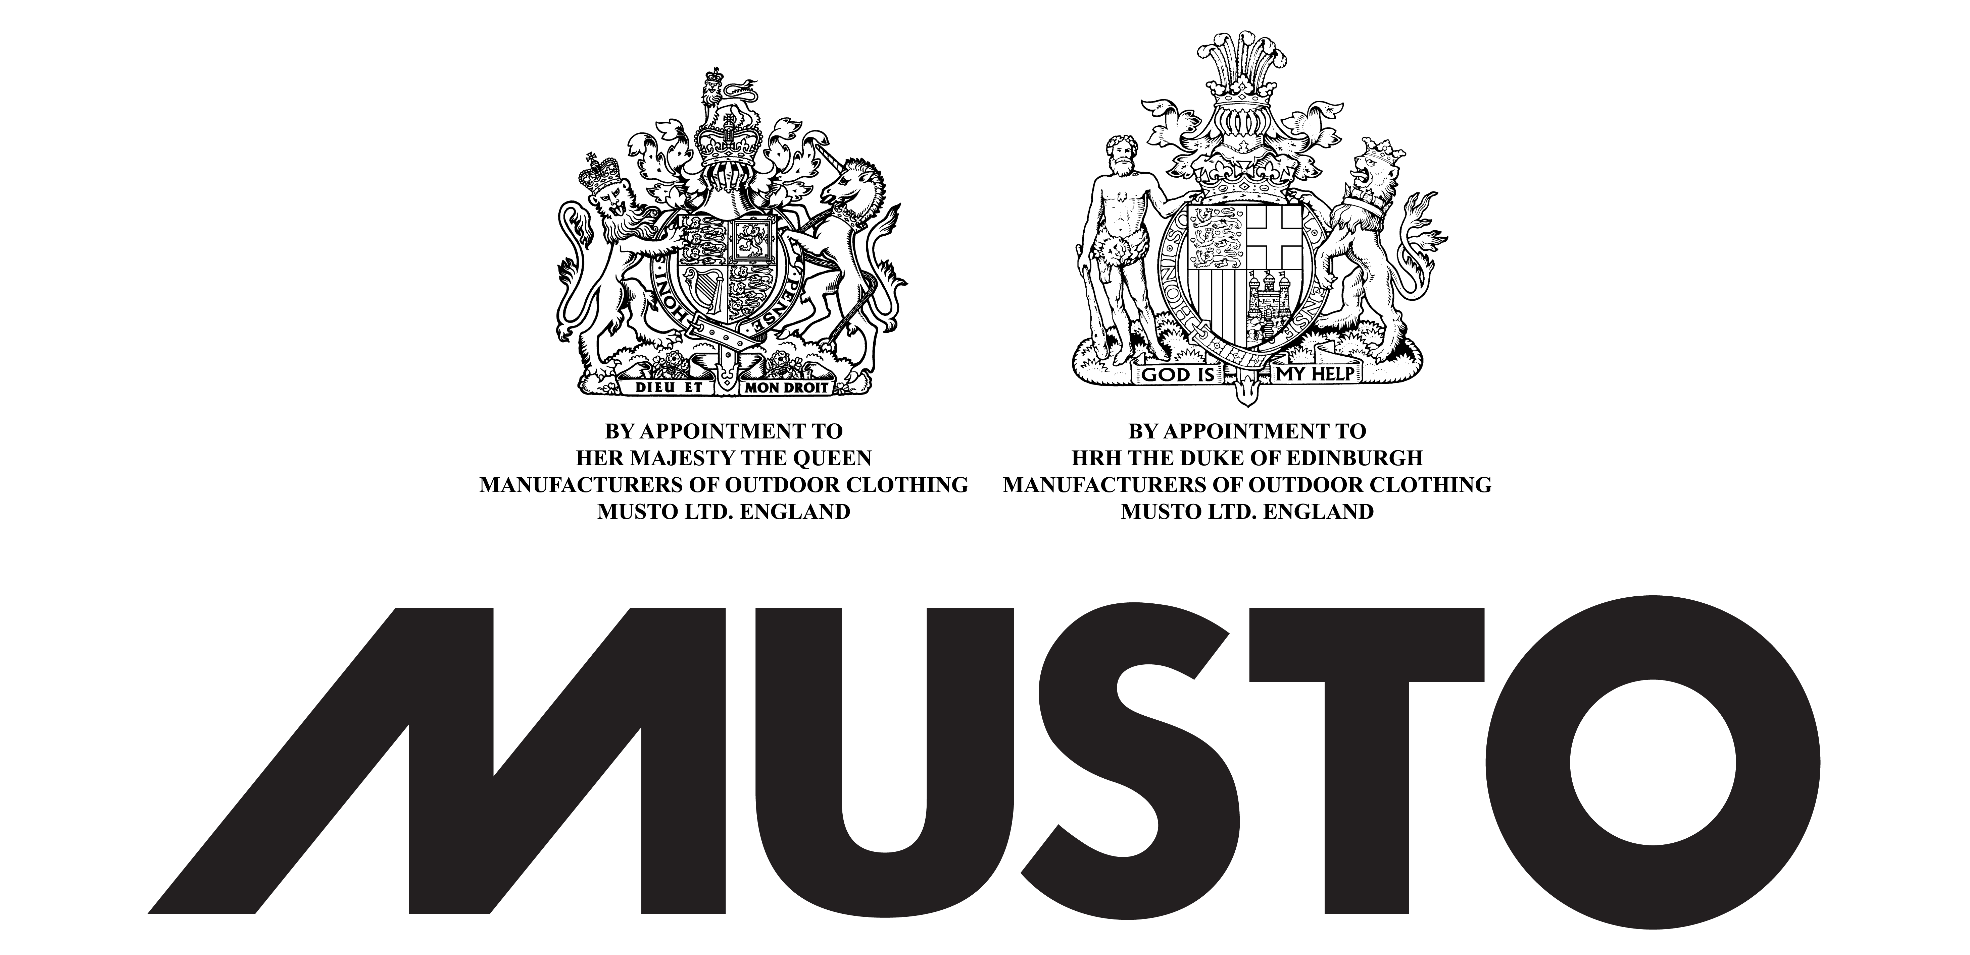

Members Name; ___________________________________________
Boat No; ________________________________
Phone No; ______________________________
Email; ____________________________________
Mail Address;________________________________________________
Post Code;____________________
Sailors have a choice of a Cap or Rashi = N.C. in the total column
Please indicate colour choice and for Woman’s clothing with (Fe) Size/Colour & quantity.
Item | Size & No | Identification | Musto | Unit Price | Total
Nomination Fee |  |  |  | $350
Late Fee |  |  |  | $50
Non-Fireball Sailors |  | All inclusive | Membership Temporary  Nomination Fee | $400
HAT |  | AL1410 | FAST DRY BRIMMED HAT | $30
CAP |  | PAL0030CC | FD CAP | $21
SHORT SLEIVE SHIRT |  | PMP24227CC | TIPPED PIQUE POLO | $58
LONG SLEIVE SHIRT |  | SE0264 | EVOLUTION FD L/S POLO | $69
SHORT SLEEVE SHIRT |  | MP24227CC | PIQUE POLO | $50
Rashi |  | KS007JO | DINGHY UV FD L/S | $34
Fast Dry shorts |  | SE0791 |  | $85
Sardinia Jacket |  | SB0101 |  | $164
Dinghy Smock |  | SO0012 |  | $175
OPENING DINNER  Non Competitor |  | Over 12 years of age |  | $15
OPENING DINNER |  | Under 12 years of age |  | $5
PRESENTATION DINNER  Non Competitor |  | Over 12 years of age |  | $20
PRESENTATION DINNER |  | Under 12 years of age |  | $5

Subtotal:
Balance Due:
Please Note; Clothing must be paid for when placing your order.
Extra Sizes Make a note in the size and no column, Add the total cost in the price column; then include all in the section at the end.
CLOSING DATE FOR CLOTHING 3rd Feb 2017 Use the size &no column for Female ,this date is for printing of shirts and Rassi’s.
Closing date for all clothing is 10th Feb.

,designation

Crews please use this when ordering extra tickets for Family and Friends, plus additions for clothing, use your boat no for additional identification

IFASA Treasurer Pete Allison email peteally64@gmail.com

BSB: 085397. …Account No. 772240258; use your sail no
Please C.c. to Joel joelcoultas@gmail.com and Dave dmd123@bigpond.com

SIGN UP

SB0101 Sardinia Jacket http://www.musto.com.au/products/sardinia-br1-jacket-black
SE0791 Fast Dry shorts
http://www.musto.com.au/products/essential-fast-dry-shorts-light-stone
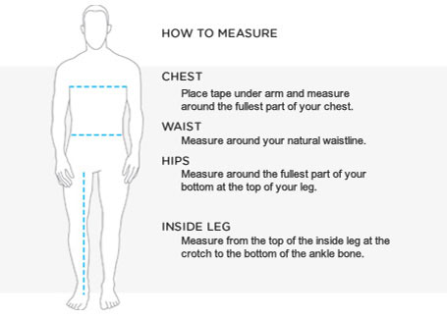

- Male Sizes

Jackets & Tops
Musto Size | X Small | Small | Medium | Large | X Large | XX Large | XXX Large
To Fit  Height | 5'2"-5'4"/  157-162cm | 5'5"-5'7"/  165-170cm | 5'8"-5'10"/  173-178cm | 5'11"-6'1"/  180-185cm | 6'2"-6'4"/  188-193cm | 6'5"-6'7"/  195-200cm | 6'5"-6'7"/  195-200cm
To Fit  Chest | 31"-33"/  79-84cm | 34"-36"/  86-91.5cm | 37"-39"/  94-99cm | 40"-42"/  101.5-106.5cm | 43"-45"/  109-114cm | 46"-48"/  117-122cm | 49"-51"/  124.5-129.5cm

Casual Trousers & Shorts
Musto Size | 30" | 32" | 34" | 36" | 38" | 40" | 42" | 44"
To Fit Waist | 30"/ 76cm | 32"/ 81cm | 34"/ 86cm | 36"/ 91.5cm | 38"/ 96.5cm | 40"/ 101.5cm | 42"/ 106.5cm | 44"/ 112cm
To Fit Regular leg | 32"/ 81cm | 32"/ 81cm | 32"/ 81cm | 32"/ 81cm | 32"/ 81cm | 32"/ 81cm | 32"/ 81cm | 32"/ 81cm
To Fit Long leg | 34"/ 86cm | 34"/ 86cm | 34"/ 86cm | 34"/ 86cm | 34"/ 86cm | 34"/ 86cm | 34"/ 86cm | 34"/ 86cm

Below sizes for Females
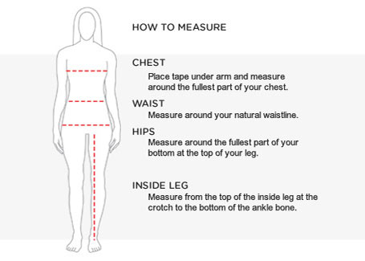

Unisex Jackets & Tops
Musto Size | X Small | Small | Medium | Large | X Large | XX Large | XXX Large
To Fit  Height | 5'2"-5'4"/  157-162cm | 5'5-5'7"/  165-170cm | 5'8-5'10"/  173-178cm | 5'11"-6'1"/  180-185cm | 6'2"-6'4"/  188-193cm | 6'5"-6'7"/  195-200cm | 6'5"-6'7"/  195-200cm
To Fit  Chest | 32"-34"/  81-86cm | 35"-37"/  89-94cm | 37"-39"/  94-99cm | 40"-42"/  101.5-106.5cm | 43"-45"/  109-114cm | 46"-48"/  117-122cm | 49"-51"/  124.5-129.5cm

Jackets & Tops
Musto Size | 8 | 10 | 12 | 14 | 16 | 18
To Fit Waist | 25"/ 64cm | 27"/ 69cm | 29"/ 74cm | 31"/ 79cm | 33"/ 84cm | 35"/ 35cm
To Fit Chest | 32"/ 81cm | 34"/ 86cm | 36"/ 91.5cm | 38"/ 96.5cm | 40"/ 101.5cm | 42"/ 106.5cm

Trousers & Shorts
Musto Size | 8 | 10 | 12 | 14 | 16 | 18
To Fit Waist | 25"/ 64cm | 27"/ 69cm | 29"/ 74cm | 31"/ 79cm | 33"/ 84cm | 35"/ 89cm
To Fit Regular Leg | 31"/ 79cm | 31"/ 79cm | 31"/ 79cm | 31"/ 79cm | 31"/ 79cm | 31"/ 79cm
To Fit Long Leg | 33"/ 84cm | 33"/ 84cm | 33"/ 84cm | 33"/ 84cm | 33"/ 84cm | 33"/ 84cm

Please note: Not all styles of trousers are available in regular and long leg.

Additional Clothing Sizes

Item | Size & No | Size & No | Size & No | Identification | Musto
HAT |  |  |  | AL1410 | FAST DRY BRIMMED HAT
CAP |  |  |  | PAL0030CC | FD CAP
SHORT SLEIVE SHIRT |  |  |  | PMP24227CC | TIPPED PIQUE POLO
EVOLUTION FD L/S POLO |  |  |  | SE0264 | EVOLUTION FD L/S POLO
PIQUE POLO |  |  |  | MP24227CC | PIQUE POLO
Rashi |  |  |  | KS007JO | DINGHY UV FD L/S
Fast Dry shorts |  |  |  | SE0791
Sardinia Jacket |  |  |  | SB0101

