Fireball Sailing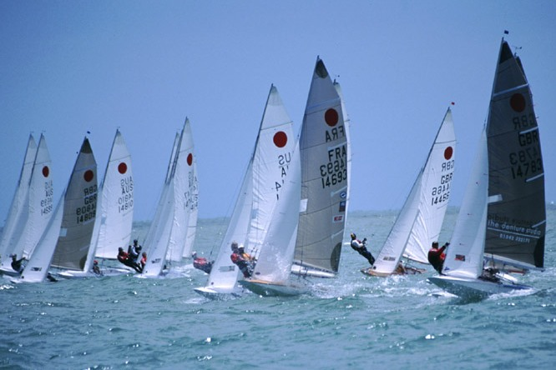

Introduction to the fireball

The fireball is a high performance two-person sailing dinghy offering exciting sailing, intense competition and a great social life off the water. It has a wide appeal as it is simple to build, reasonably priced and not too demanding to sail.
The Fireball stands out from other similar dinghies as it is –
- High performance, yet relatively forgiving,
- Can sail in almost any wind strength,
- Is suited to both lake and sea sailing,
- Can be sailed by a wide weight range of crews,
- Can be sailed by all male, all female and mixed crews,
- Age is not a restriction with sailors ranging from 14 through to 75,
- Entry level boats are available from around $1000.00,
- Boats remain competitive for many, many years,
- The class is sailed in over 40 countries worldwide,
- Fireball sailing is as much about social as racing,
- Fireballs are great fun to sail.

With an excellent race program, including club, state, national and Championships, you'll never be short of good competition, boat on boat, crew on crew. With a social side to match you'll have just as much fun off the water. Perhaps this is why over 15000 Fireballs have been sold worldwide.
Many fireballs are amateur-built, a good indication of the simplicity of the design. The fireball hull and sail plans are of strictly one design, but the class rules allow you to adapt the position and design of gear to suit your own weight and style of sailing.
Anyone can sail a fireball Age or sex does not determine one’s ability to be competitive. Some countries\' leading fireball sailors are women. The class also has a strong contingent of sailors over forty.
Winning fireball races is not really a question of having an amateur or professionally built, plywood or fibreglass, old or new boat, but rather comes down to mastering the art of tuning, and sailing better than your competition.
Fireballs are a delight to sail in strong winds. The thrills of trapeze and spinnakers are hard to match in any type of sailboat or board. If capsized, the boats are easily righted, and can be sailed without bailing. The weight and strength of the crew is not as important as the tuning of the boat. The trapeze and sail handling requires skill rather than strength.
The fireball is an international class, with fleets in every region of the world, and associations conducts yearly World, Continental, National and State Championships.
Class History
The International Fireball was designed to meet a shortcoming in the market in the 1960’s. The designer, Peter Milne, an Englishman, had these motives:
- cheapness
- simplicity to build
- unequalled performance potential for price and waterline length
- individual appearance

He achieved his aims in 1962 when the fireball was first sailed in England. The remarkable performance of his prototype was seen especially on the plane and to windward.
Without any sponsorship the class grew very rapidly, first in the UK and then on the Continent (France, Switzerland, Sweden and Germany especially), in the USA, South and East Africa, Canada, Asia, Australia, New Zealand and the Pacific Islands.
Within a very short time the need for worldwide administration became apparent and "Fireball International" had to be formed. To this body the newly formed National Associations affiliated. A constitution and detailed class rules were adopted.
The first World Championships were held in England in 1966. In 1968 the spinnaker was internationally adopted.
The class was recommended by OYRU for International status and was approved in 1970. The class has been a close contender for Olympic selection. It has established a worldwide reputation for its high standards of yachting administration and progressive enthusiasm.
Fireball sailing has continued to grow through the decades. The Fireball class can boast to being the strongest of the traditional classes worldwide. The strength of the original design shows through, with little need to make changes to keep the class competitive in the market place.
In a world where new shiny plastic classes come and go, the Fireball remains strong and extremely popular. You only have to take part in a regatta and to enjoy the on and off water comradery to understand why.

Designer | Peter Milne from UK
Year first built | 1962
Crew | 2
Trapeze | Single
Length over all | 4.63 metres
Beam | 1.37 metres
Hull weight | 79.4 kg
Overall rigged weight | 103 kg
Fixed sail area | 11.43m square
Spinnaker sail area | 13.01m square
Construction | Timber or Fibreglass, Kevlar, foam sandwich
Combined crew weight | 120 – 180kg
Sailor’s age range | 14 – 75 years
Median age | 35 years
Number of boats built worldwide | 15000+
Number of boats sailing worldwide | 500+

